**Understanding the school-based health consent form**

**PART ONE:**

The questions below are basic demographic information to make sure we have the correct student.

By having the primary care provider or practice information, it informs the Adena Health team on who to work with to make sure they are aware of any health care services provided to you student by Adena Health.

**Patient / Student Information:**

Patient/Student, First and Last Name Parent/Legal Guardian, First and Last Name

Street Address City State Zip Code

Phone Number Date of Birth (Month-Day-Year) School & Grade Level

Primary Care Provider Primary Care Provider’s Phone Number

Primary Care Provider’s Street Address City State Zip Code

**PART TWO:**

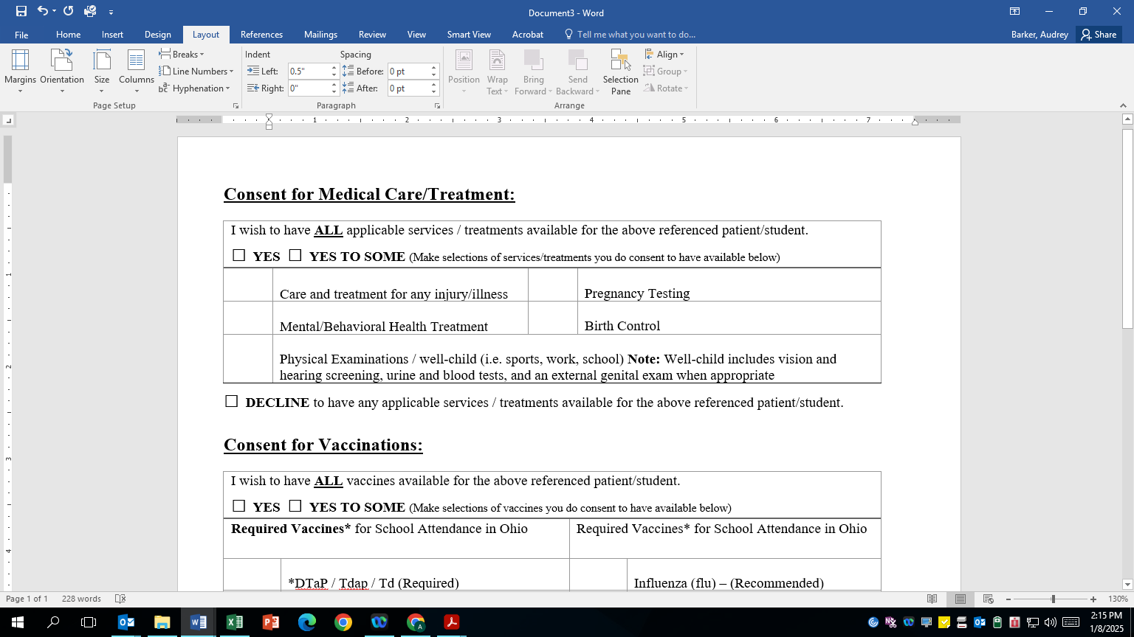

Your child will not be seen for anything by Adena Health when at the school. School nurse and emergency services will still be available to them by the school.

This means there are some services you would like available to your child. Mark the items you agree for your child to be seen for. Leave the ones you do not agree to blank.

This means you want all services available to your child, should they need them.

**PART THREE:**

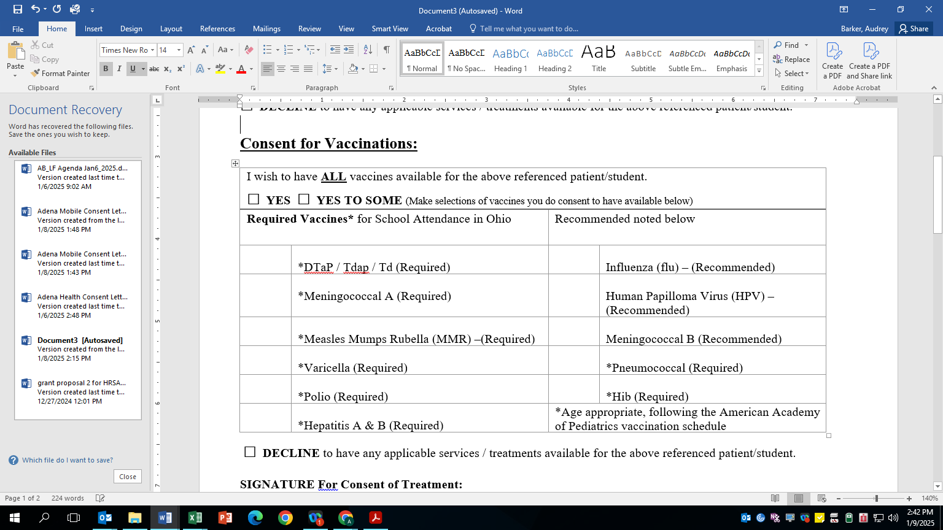

This means there are some vaccinations you would like available to your child. Mark the items you agree for your child to receive. Leave the ones you do not agree to blank.

This means you will allow Adena Health to provide any vaccinations your child is due to have.

Your child will not receive ANY vaccines from Adena Health without parental or guardian approval. School nurse and emergency services will still be available to them by the school.

* Any REQUIRED vaccinations for school attendance, please work with the school district to make sure they have all documentation needed.
* Adena Health will NOT provide any vaccinations to a minor that has not been approved by their parent or guardian.

**PART FOUR:**

Signatures from the parent or legal guardian are REQUIRED, whether you marked “YES”, “YES to SOME” services or DECLINED all services.

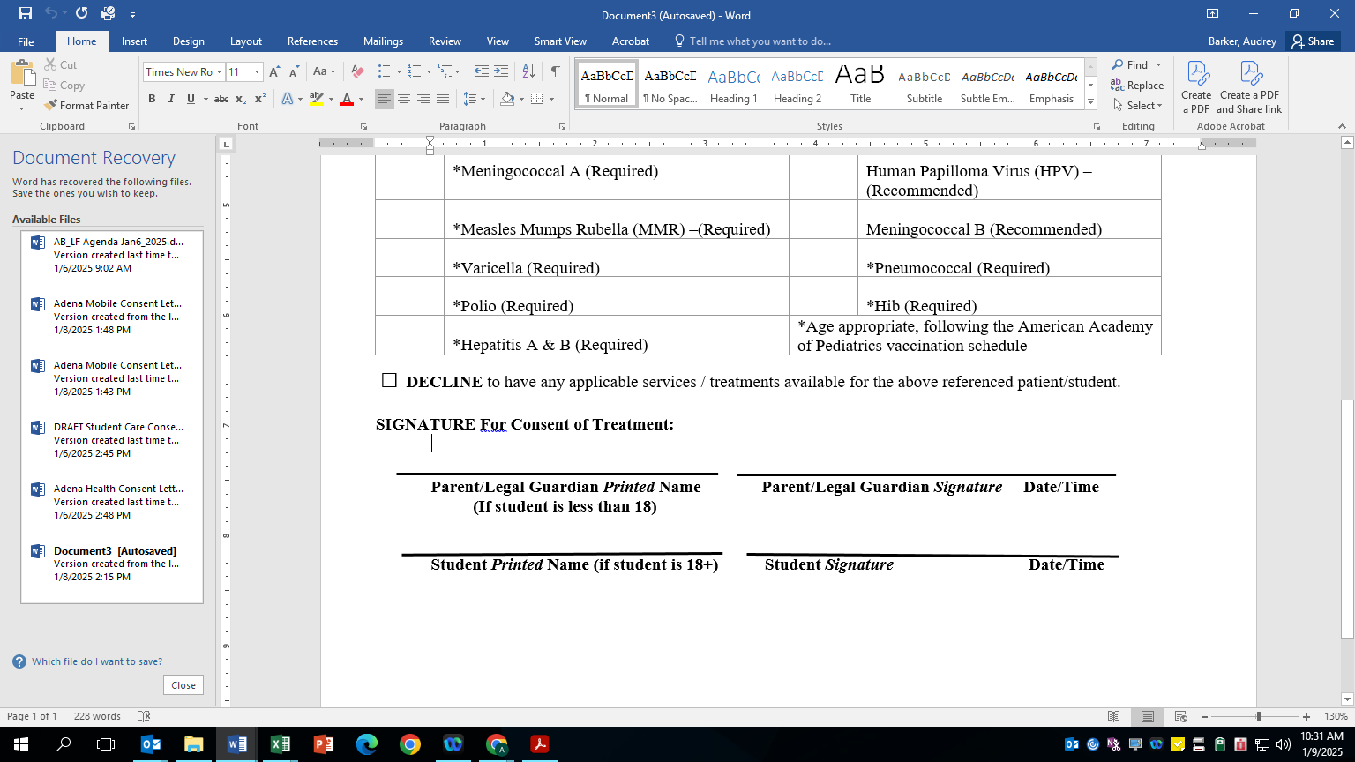

**PART FIVE:**

**Authorization to Release Medical Information**

* Below is information on what can be provided through ANY primary care/ family medicine clinic in Ohio. This is NOT only something Adena Health does, but ALL clinics in the State of Ohio:

*There are a few instances in which we can provide treatment and/or testing to your minor child without parent/legal guardians consent* ***under Ohio law.*** *Provided below are those instances:*

* *STD testing and treatment, *HIV/AIDS is limited to testing only*
* *Drug or alcohol abuse and treatment*
* *Mental health services if 14 years or older and only for a limited period of time, *not including medication.*
* *Sexual assault examination*
* Other items to note:
* *The consent for treatment will remain valid for one year from the signed date below.*
* *You may revoke or makes changes at any time by making a written request to AHS.*
* *Adena Health will call to get verbal consent for the child to be seen and to share information with the school. If verbal consent is not received and the consent is not signed, the child will not be seen nor information shared.*

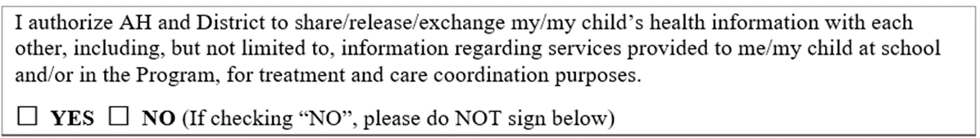

Marking “YES” allows us to share important information with the school that can help your child in the classroom and at home.

IF marking “NO”, your child may still be seen for service, but no information will be shared with the school.

**PART SIX:**

* Do NOT sign if you marked “NO” in the box above this signature line.
* If you marked “YES”, parents or legal guardians please sign the signature line available on the form.
* If you are student that is 18 years of age, you can sign below, in place of the parent or legal guardian.

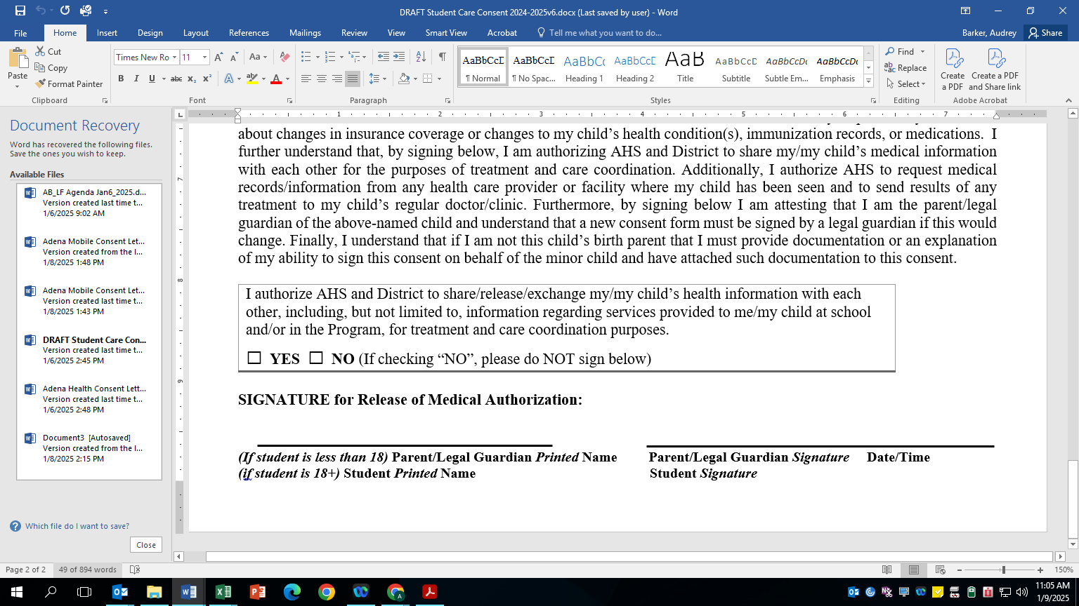

Should you need further assistance, the Adena Health main switchboard can be reached at 740-779-7500, or if you need help finding a provider, call 740-779-FIND (3463).