Dear Patient,

Adena Health System has partnered with CIOX Health, the nation’s largest provider of release of medical information services, to process and fulfill your request for a copy of your medical record.

A CIOX Health Information Specialist digitally captures your protected health information from the facility’s medical record through our confidential, secure technology platform. Your medical record information is then digitally transmitted to our Release of Information Processing Center, where it is packaged and mailed or electronically sent to you, via our eDelivery functionality, all in a HIPAA-compliant format.

Due to the strict procedural and highly regulated steps involved in this process, known as the release of information process, there are costs associated and, therefore, a fee for this service based on regulated rates, which are:
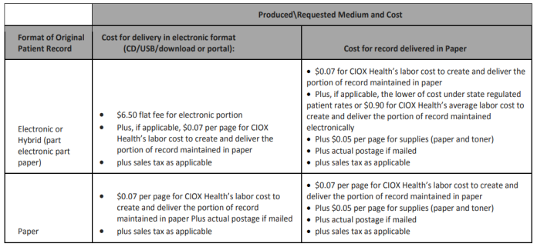
The above fees are for patient access requests only and all other requests will be subject to the state regulated fee schedule.

While CIOX Health is under contract with this facility to provide release of information services, we are also committed to providing you with your requested medical record in an efficient and highly secure manner and want to make sure you understand the process in which your records are provided and the costs associated with obtaining them.

Our standard processing time to respond to your request is 7 to 14 business days. Please don’t hesitate to contact us at 740-779-7640 if you have any questions about the service CIOX Health provides on the facility’s behalf, or the bill you may receive as a result of your request for medical records.

Thank You,
CIOX Health

Please note: There is no fee for medical record requests sent directly to a physician or
healthcare facility for continuing care purposes.

